Module 8: Portfolio Project

Bryan Moffett
Colorado State University Global
ITS410: Database Management
Dr. Raquel Hicks
October 11th, 2026

Final Reflection and Advanced SQL Query with My Guitar Shop
Introduction
Effective organization, retrieval, and protection of data are central to modern information technology systems. Throughout ITS410, the study of relational database management systems moved beyond basic query construction toward a deeper understanding of enterprise database architecture. Applying relational principles using MySQL Workbench provided practical experience in structuring datasets, executing multi-level administrative queries, and enforcing secure access controls. This reflection summarizes key technical concepts learned during the course, explores their practical applications in enterprise scenarios, and outlines future areas for professional development in database administration and software engineering.
Key Lessons Learned
Relational data modeling and advanced multi-table joins demonstrated the importance of database integrity. Learning to structure unstructured data into normalized relational models highlighted this principle. Dividing complex systems into distinct, normalized tables, such as separating customer data, orders, addresses, and line items, prevents data redundancy and deletion anomalies. Mastering inner and outer join logic made it possible to reconnect these entities using primary and foreign keys, allowing complex reporting views to be constructed without compromising normalization standards.
Multilevel aggregation and grouping with ROLLUP showed how efficient summary operations can generate actionable business intelligence within the database engine. Working with aggregate functions such as COUNT, SUM, and the WITH ROLLUP extension demonstrated how MySQL can calculate detailed transactional records, category subtotals, and grand totals in a single execution pass. Distinguishing between row level filtering with WHERE clauses and post aggregation filtering with HAVING clauses also clarified how the query optimizer evaluates grouped datasets.
Effective data security, access control, and privilege management require policies that protect sensitive information. Writing CREATE USER and GRANT statements reinforced the principle of least privilege. Assigning read and write access only to necessary transactional tables, while limiting static catalogs to read only access, showed how table level permissions can prevent unauthorized changes and reduce security risks.
Real World Application
System optimization and data integrity are closely connected in enterprise environments, where poorly structured queries and overly permissive user accounts can introduce performance bottlenecks and security vulnerabilities. Applying third normal form principles maintains data integrity across transactional processing systems. Using database native aggregation functions also allows analytical reports to be processed directly on the database server, reducing network latency and memory overhead compared with pulling raw datasets into application memory.
A practical secure reporting scenario can be illustrated through an enterprise ecommerce platform that requires a dedicated background service to process end-of-the-month financial reports and update order fulfillment statuses without altering product pricing or database configurations. Using the administrative concepts from this course, an engineer can establish a network restricted user account bound to a specific institutional domain. The service account receives data manipulation rights on orders and addresses, while product and category tables remain read only. The reporting service can then run optimized WITH ROLLUP queries to retrieve multitiered sales summaries across categories in a single request, keeping network utilization low and security intact.
Personal Growth and Future Readiness
Career preparation and confidence grew through coursework in database design, SQL script development, and access governance. Tasks that initially presented challenges, such as debugging complex multi-table joins, structuring conditional HAVING clauses, and managing granular user grants, have become routine procedures. Incorporating defensive scripting practices, including IF NOT EXISTS conditions, helps ensure that database deployment scripts remain idempotent and reliable across development environments.
Professional growth and next steps will focus on database performance tuning and advanced architectural patterns. Priority areas for continued learning include analyzing query execution plans with EXPLAIN, optimizing B tree indexes for large datasets, writing stored procedures and triggers to enforce business rules at the database level, and evaluating how relational databases integrate with NoSQL stores and caching layers in microservice architectures.
Conclusion
ITS410 provided a comprehensive foundation in relational database management, successfully linking theoretical database concepts with practical, production ready execution. Mastering advanced querying techniques, aggregate reporting, and granular security management has established a strong framework for designing, maintaining, and securing enterprise data architectures in future professional roles.
Part 2: Task 1.4 - Calculate Discount Amounts and Prices
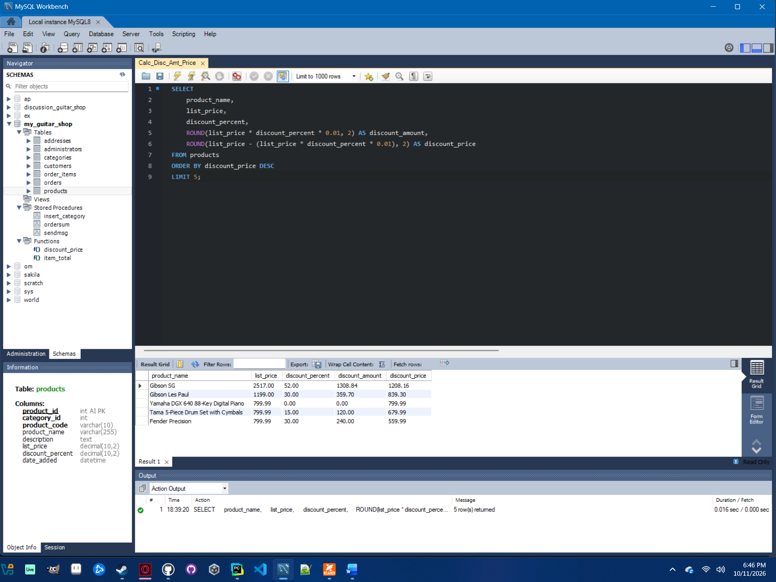

Part 2: Task 2.4 - Analyze Item Totals from Order_Items
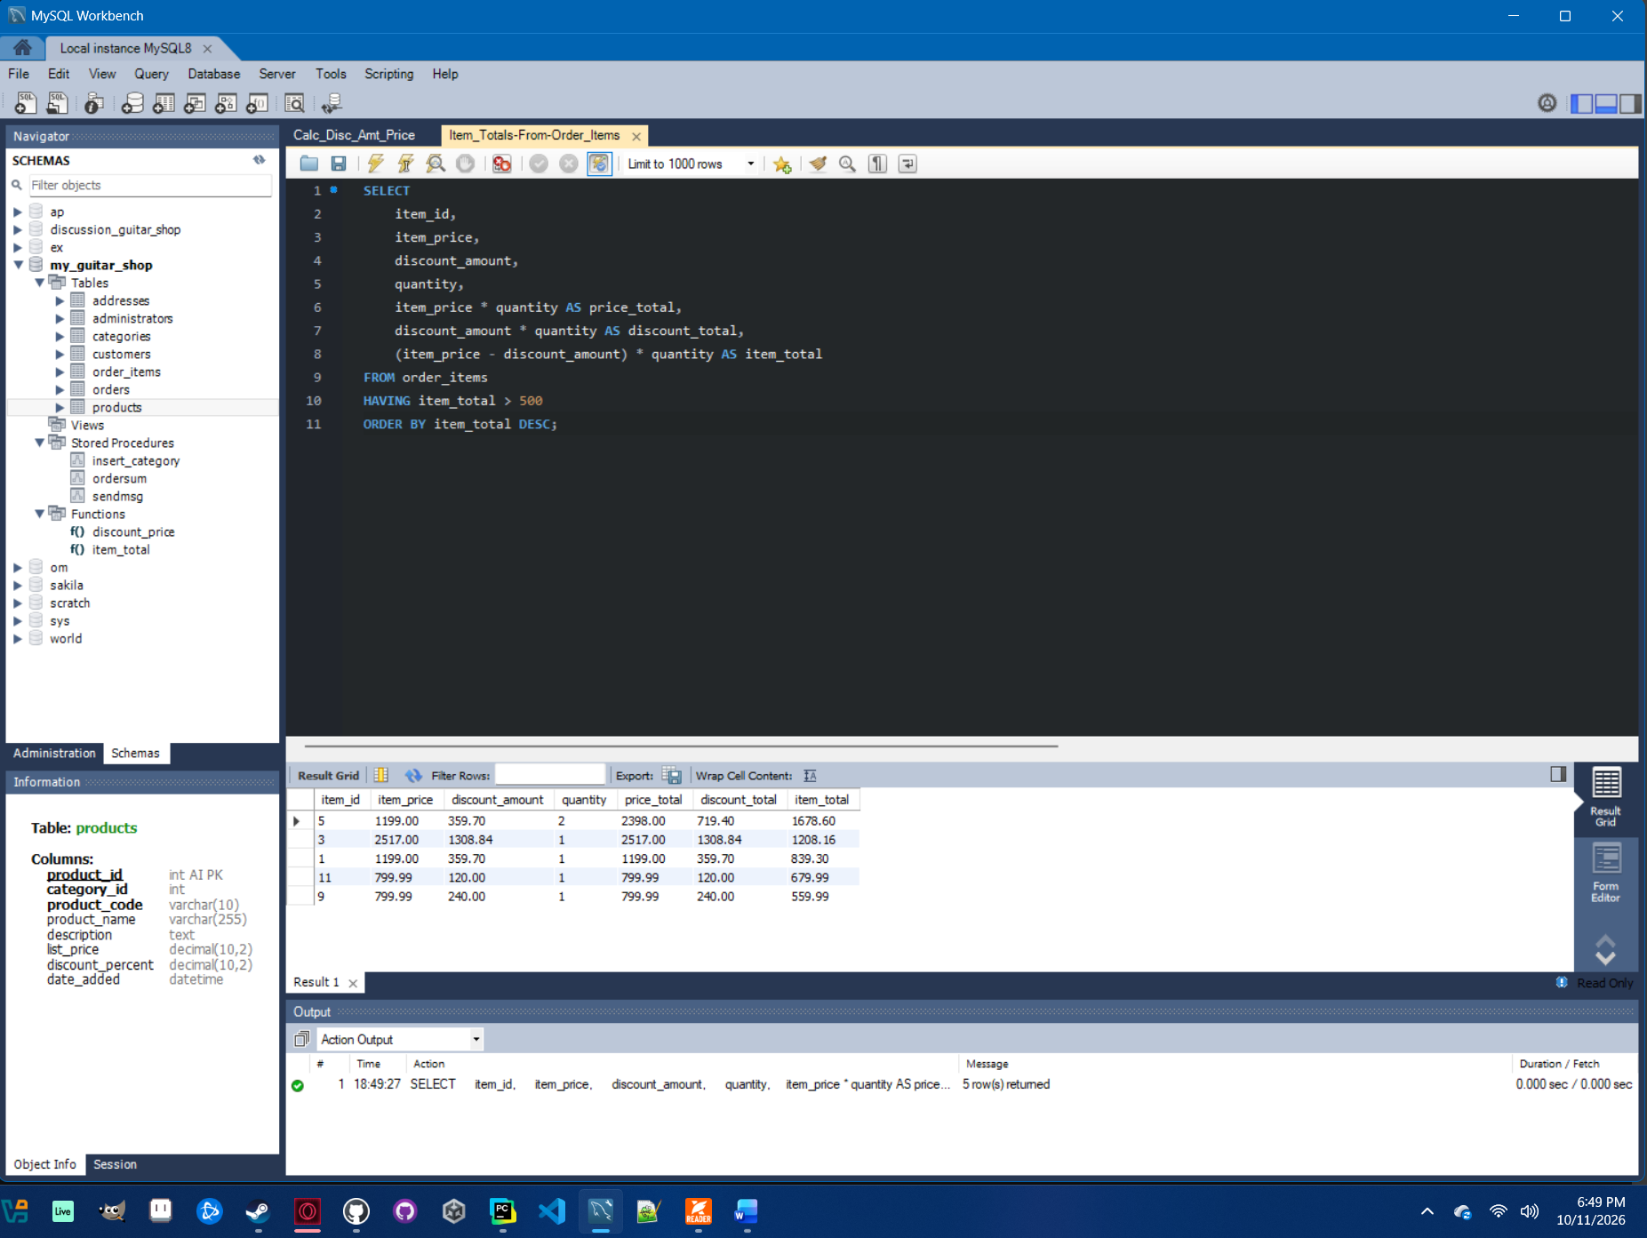

Part 2: Task 3.4 - Identify Products with Matching Prices
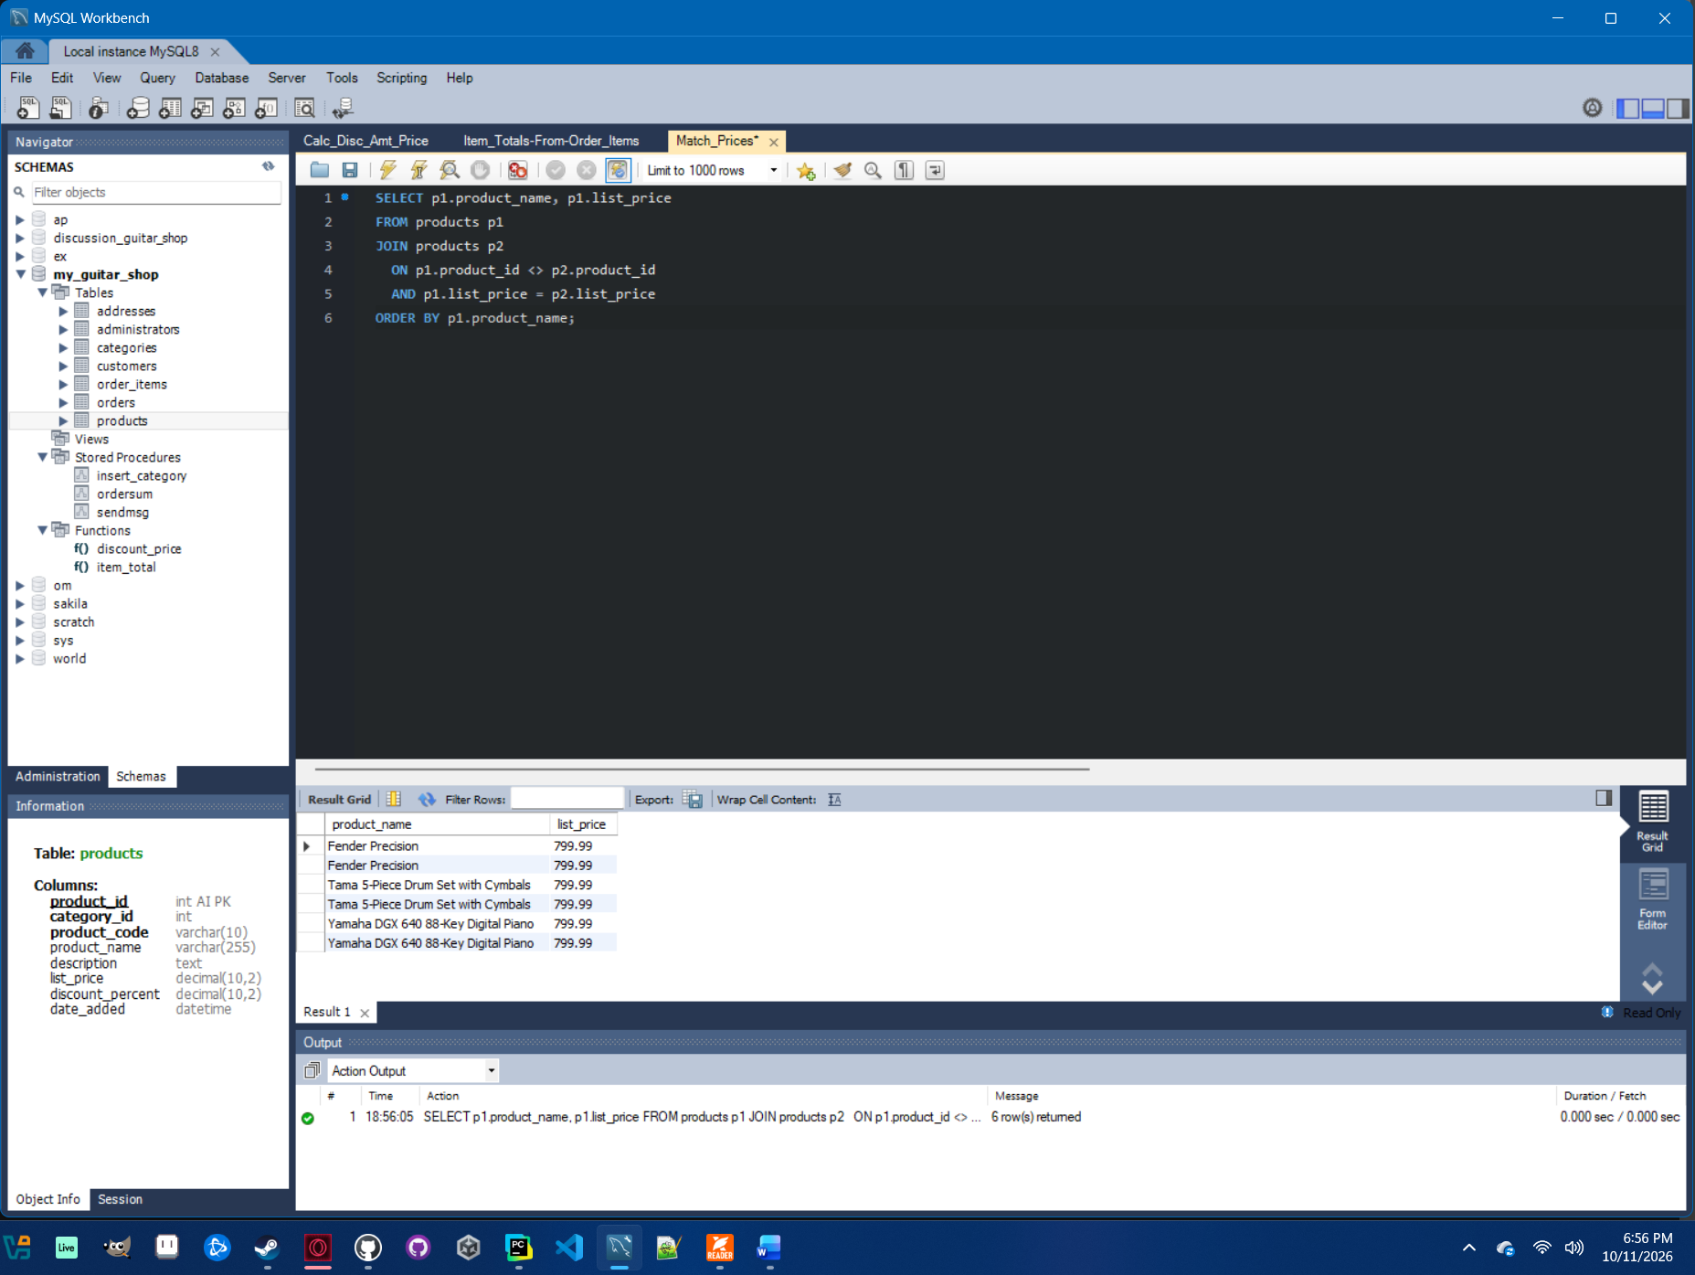

Part 2: Task 4.3 - Find Unused Categories

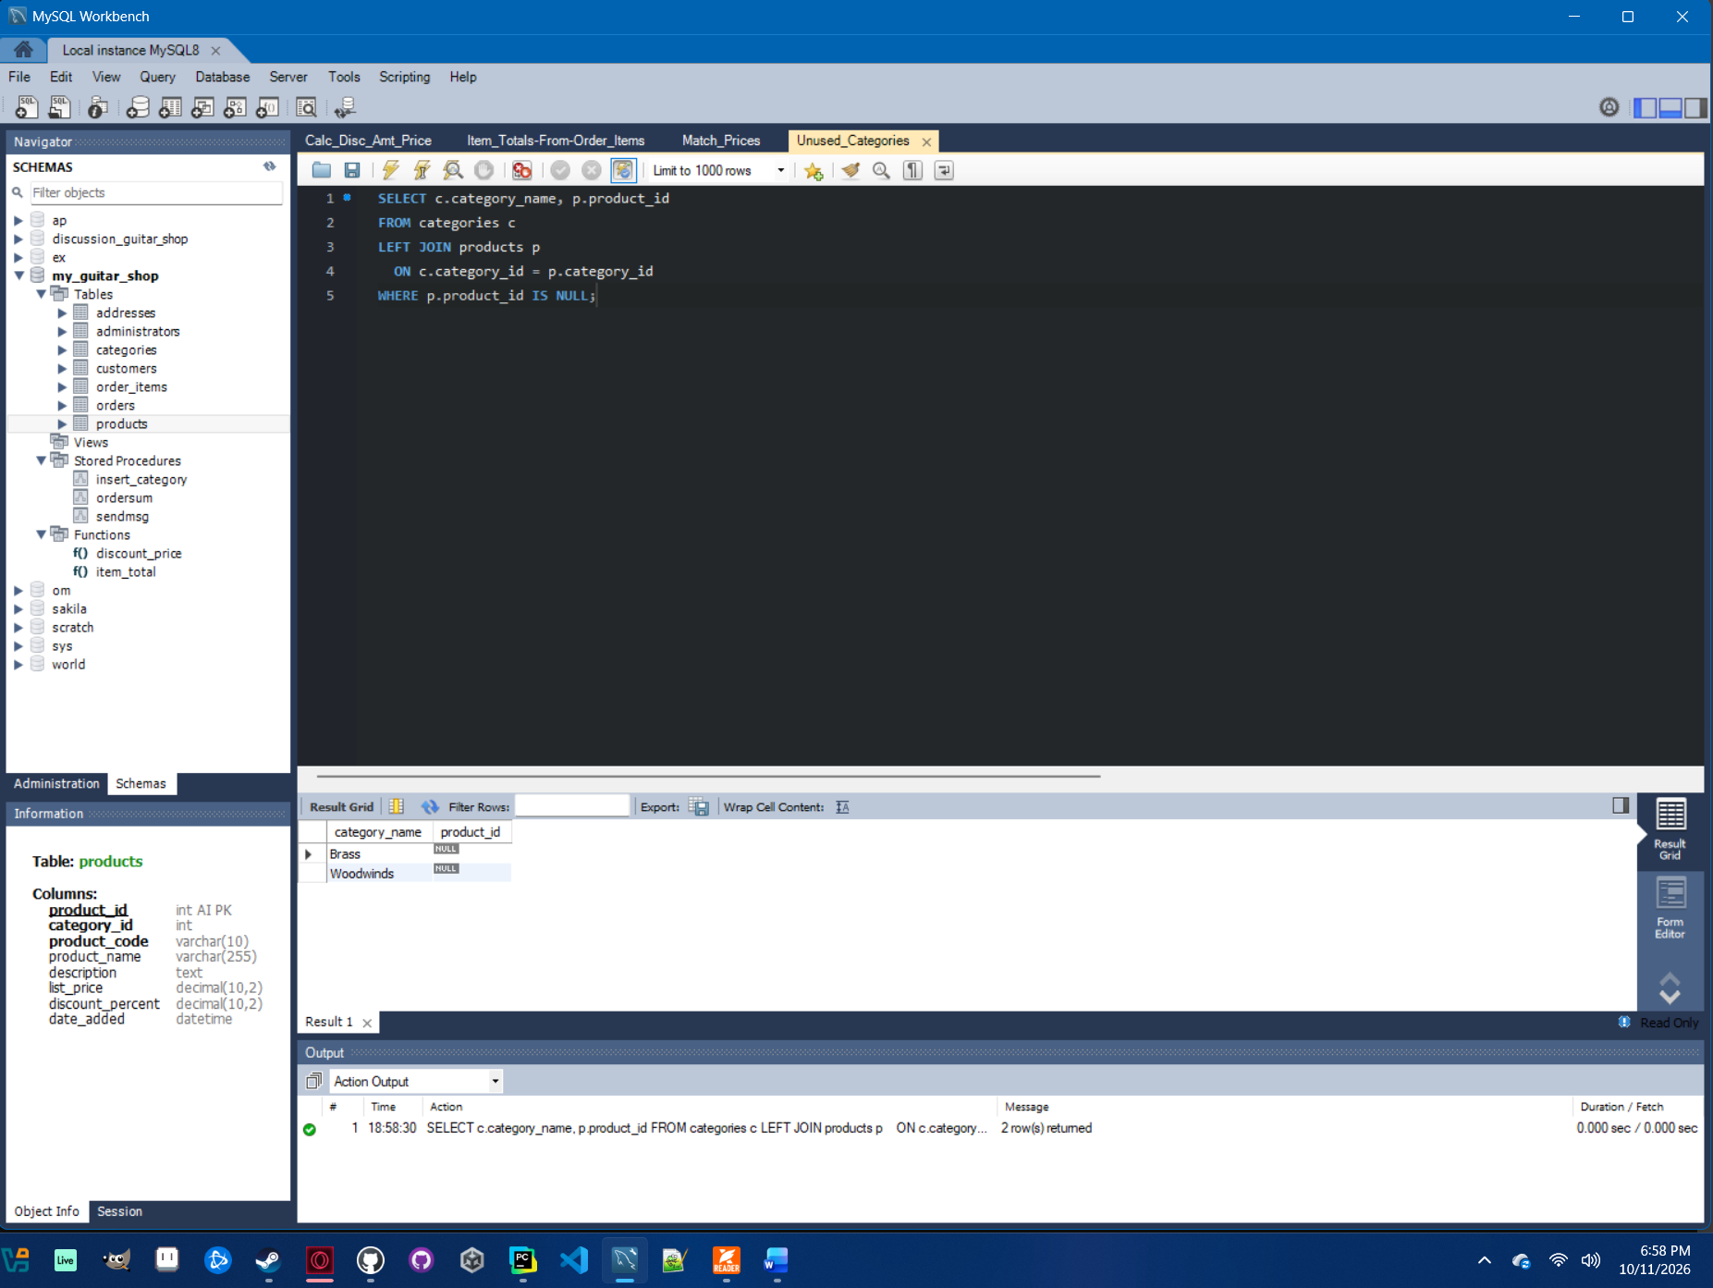

Part 2: Task 5.3 – Insert a New Customer

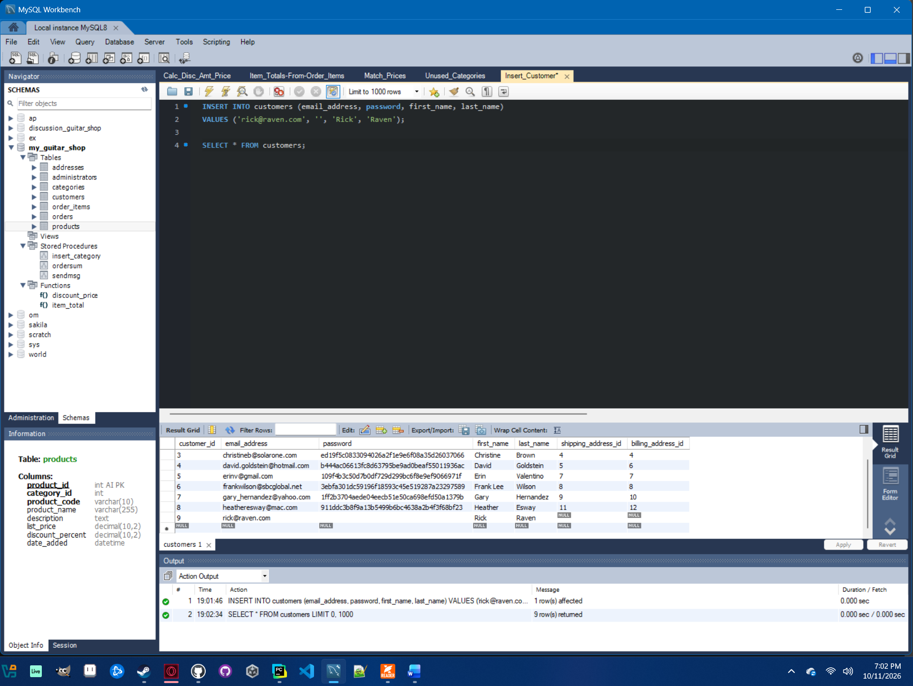

Part 2: Task 6.3 - Find Customers with Multiple Products Ordered

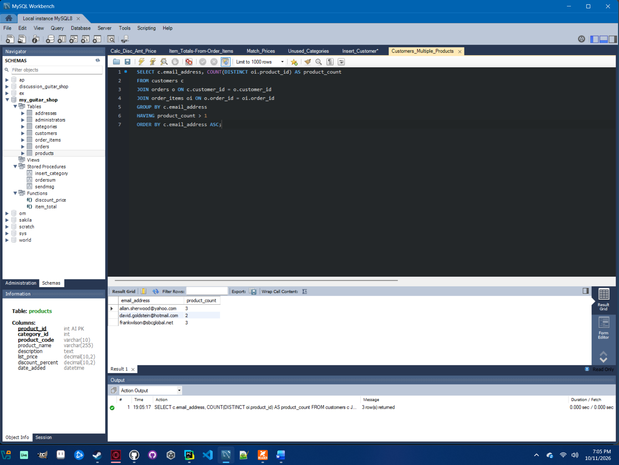

Part 2: Task 7.4 - Show Product Quantities by Category with ROLLUP

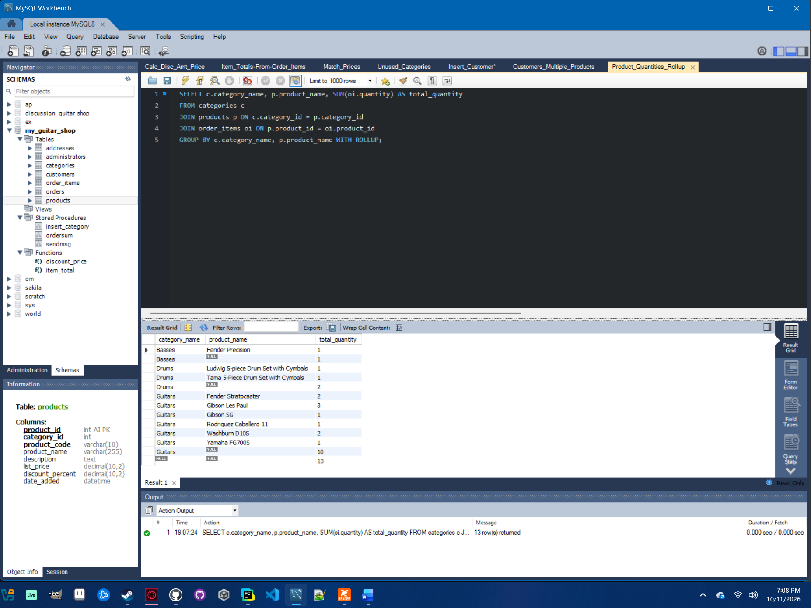

Part 2: Task 8.4 - Create and Grant Privileges to a New User

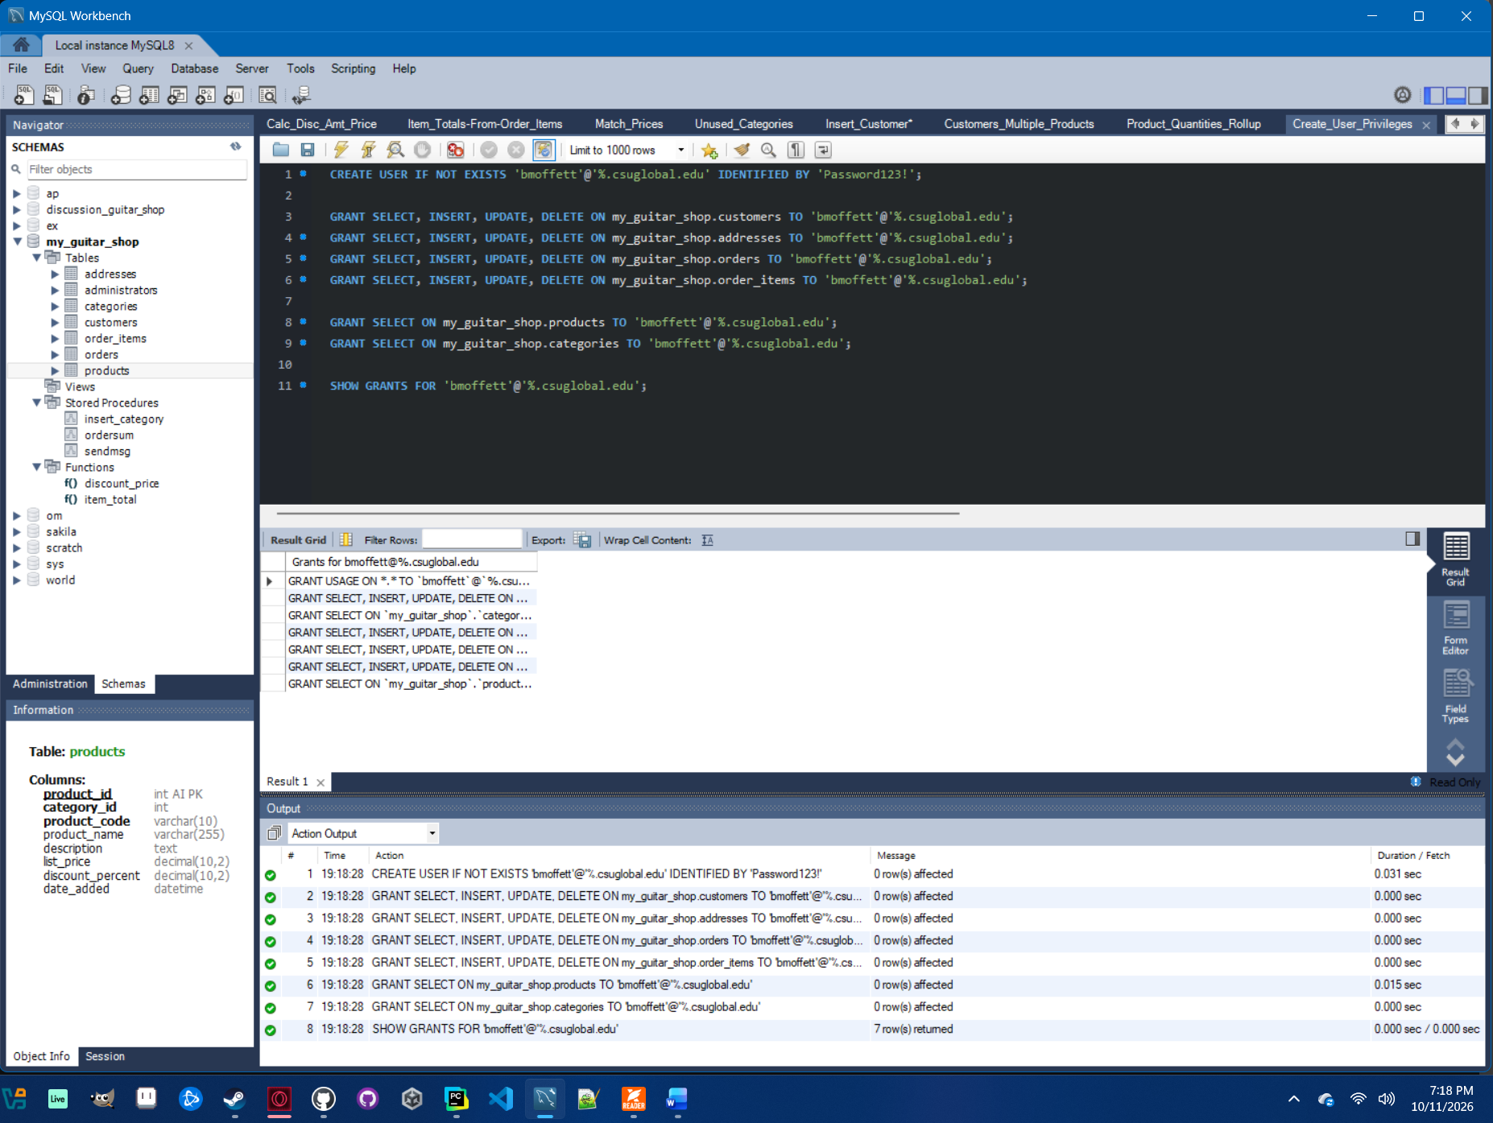

References

Murach, J. (2019). Murach’s MySQL (3rd ed.). Murach Books.

